
Department of Computer Science and IT,
Barani Institute of Management Sciences,
Rawalpindi Pakistan

Project Name

By

Muhammad Ali 22-ARID-5404
Daniyal Rashid 21-ARID-4682

Supervisor
Miss Afifa
Bachelor of Science in Computer Science (2021-2027)

The candidate confirms that the work submitted is their own and appropriate
credit has been given where reference has been made to the work of others.

DECLARATION

We hereby declare that this software, neither whole nor as a part has been copied out from any source. It is further declared that we have developed this software documentation and accompanied report entirely on the basis of our personal efforts. If any part of this project is proved to be copied out from any source or found to be reproduction of some other. We will stand by the consequences. No Portion of the work presented has been submitted of any application for any other degree or qualification of this or any other university or institute of learning.

Muhammad Ali Daniyal Rashid

--------------------------- --------------------------- ---------------------------
CERTIFICATE OF APPROVAL

It is to certify that the final year project of BS (CS) “AI BASED TRAVEL ASSISTANT” was developed by “Muhammad Ali, 22-ARID-5404”, “Daniyal Rashid, 21-ARID-4682” under the supervision of “Miss AFIFA” and that in their opinion; it is fully adequate, in scope and quality for the degree of Bachelors of Science in Computer Science.

---------------------------------------
Supervisor

---------------------------------------
Administrator UIIT

Executive Summary
The Travel Assistant Recommendation System is a web-based AI-powered travel planning platform that helps users find both the fastest and most scenic or tourist-friendly routes between two locations. The system is designed to bridge the gap between traditional navigation tools, which focus solely on speed and efficiency, and tourism platforms that provide information on attractions but lack routing capabilities. This fragmentation often forces users to switch between different apps during trip planning, resulting in an inefficient and disconnected experience.
To solve this, the system allows users to input their origin, destination, trip duration, and interests. What distinguishes this project is the integration of Natural Language Processing (NLP), which enables the system to interpret free-text user queries such as “I want a peaceful trip with gardens and historical places” and automatically translate them into relevant filters like parks and heritage sites. Using this approach, the user no longer has to rely on checkbox based filters. This makes the system more intelligent, user-friendly, and flexible for travelers with diverse preferences.
The system generates two route options: one optimized for speed and another enriched with suggested Points of Interest (POIs) such as parks, museums, historical landmarks, or shopping areas — all based on the extracted keywords from the user’s input. Before the route is shown, the system presents previews of these POIs including names, categories, distances, and images.
In addition, the system enhances travel planning by combining multiple services into a single platform. Instead of depending on separate applications for navigation and tourism discovery, users can perform all tasks within one integrated environment. This not only improves efficiency but also saves time and effort during trip planning.
Technically, the platform is developed using Flutter, MySQL and Python for backend processing and NLP integration, and MySQL for storing user and trip data. It utilizes open-source APIs like OpenStreetMap for map rendering, Open Route Service for route generation, Nominatim for geocoding, and Overpass API for fetching real-time POIs. Python’s NLP libraries such as spaCy or NLTK are used to extract keywords and match them with relevant POI categories.
Furthermore, the system is designed with scalability and usability in mind. It can be extended to include additional features such as hotel booking, travel recommendations based on user history, and integration with external services. This makes it suitable not only for individual users but also for promoting local tourism and supporting travel-related businesses.
By combining route planning, tourist discovery, AI-driven natural language interpretation, and simple booking facilitation, this project delivers a complete and modern travel assistant experience. It is designed to support both individual travelers and local tourism promotion, with the potential to scale into larger applications.

Acknowledgement

All praise is to Almighty Allah who bestowed upon us a minute portion of His boundless knowledge by virtue of which we were able to accomplish this challenging task.
We are greatly indebted to our project supervisor “Ms. Afifa” for personal supervision, advice, valuable guidance and completion of this project. We are deeply indebted to her for encouragement and continual help during this work.
We will not be out of place to express my profound admiration for our parents for their continued prayers and support. It was only possible due to their moral support that we continued our education. Many thanks to our colleagues, friends, and cousins who never let us down in hard times.
We always pray for the individuals we mentioned, who helped us to succeed in this and everlasting life. Ameen

Muhammad Ali Daniyal Rashid

--------------------------- ---------------------------

Table of Contents

Chapter 1: Introduction
1.1 Brief ........................................................................................................................ 9
1.2 Relevance to Course Modules .................................................................................10
1.3 Project Background .................................................................................................11
1.4 Literature Review ....................................................................................................12
1.5 Analysis from Literature Review ............................................................................13
1.6 Methodology and Software Lifecycle .....................................................................13
1.6.1 Rationale behind Selected Methodology ............................................................14
Chapter 2: Problem Definition
2.1 Problem Statement ..................................................................................................15
2.2 Deliverables and Development Requirements ........................................................16
2.3 Current System ........................................................................................................16
Chapter 3: Requirement Analysis
3.1 Use Cases .................................................................................................................17
3.2 Functional Requirements .........................................................................................18
3.3 Non-Functional Requirements .................................................................................19
3.4 Sequence Diagram ...................................................................................................20
3.5 Activity Diagram .....................................................................................................22
3.6 Class Diagram .........................................................................................................24
3.7 Roles Diagram .........................................................................................................26
References .....................................................................................................................27

List of Figures
Figure 3.1: Use Case Diagram of AI-Based Travel Assistant System ......................... 18
Figure 3.2: Sequence Diagram of AI-Based Travel Assistant System ......................... 21
Figure 3.3: Activity Diagram of AI-Based Travel Assistant System ........................... 23
Figure 3.4: Class Diagram of AI-Based Travel Assistant System ............................... 25
Figure 3.5: Roles Diagram of AI-Based Travel Assistant System ............................... 26

LIST OF TABLES

Table 1.1: Research Papers Summary Table ..................................... 14

Chapter 1: Introduction
This Chapter introduces the Travel Assistant Recommendation System, explaining why existing navigation and tourism tools are insufficient for modern travelers. It outlines the project’s objectives, the role of Natural Language Processing (NLP) in interpreting user requests, and the open-source technologies that power the platform. Background context highlights the need for an integrated routing-plus-tourism solution, while the literature review positions this work against prior research. Altogether, the chapter sets the conceptual foundation for the project.

Brief
In today’s digital landscape, navigation and travel planning tools have become essential for everyday movement. While many applications are available, most are limited in scope — either they focus purely on the fastest route (e.g., Google Maps) or they suggest places to visit without integration into the journey itself (e.g., TripAdvisor). As travel becomes more personalized, users increasingly expect smarter tools that can recommend not just where to go, but what to see along the way. This project proposes a smart web-based Travel Assistant Recommendation System that generates both the fastest route and a tourist-friendly route between two locations. One of the key innovations in this system is the use of Natural Language Processing (NLP), which allows users to describe the type of trip they want in plain English. For example, a user may say “I want to explore shopping malls and food streets,” and the system will intelligently apply the correct filters without the need for checkboxes or dropdowns. This not only improves the user experience but also adds a layer of AI functionality to the application. The system is built using web development tools including Flutter, MySQL and Python. It integrates free APIs such as OpenStreetMap, Nominatim, OpenRouteService, and Overpass API to fetch maps, coordinates, route data, and filtered tourist spots. By combining these technologies, the project delivers an efficient, AI-enabled platform that makes travel planning more interactive, intelligent, and effective.

Relevance to Course Modules
- The AI-Based Travel Assistant System integrates concepts studied throughout the BS Computer Science program and applies them in a practical intelligent system. The project relates to Artificial Intelligence, as it incorporates Natural Language Processing (NLP) using Python to interpret user travel queries and generate personalized recommendations. It applies principles from Software Engineering, including requirement analysis, system modelling using UML diagrams, and Agile-based development methodology.
- The system also utilizes concepts from Database Management Systems through structured data storage and management using MySQL. This ensures efficient handling of user data, trip information, and system-generated recommendations. Furthermore, the project is developed using Flutter, which applies knowledge from Mobile Application Development and modern programming practices for building cross-platform applications.
- In addition to technical implementation, the project reflects an understanding of integrating multiple domains into a single intelligent system. It demonstrates how Artificial Intelligence techniques can enhance user experience by making systems more interactive and adaptive to user needs. The use of NLP allows the system to process natural language input, reducing the dependency on rigid user interfaces such as dropdowns and checkboxes.
- Moreover, the project highlights the importance of software engineering practices in real-world development. From requirement gathering to system design and implementation, each phase reflects concepts learned during the academic program. The use of Agile methodology ensures continuous improvement and adaptability, which is essential for modern software systems.
- Overall, the project demonstrates the integration of AI, software engineering principles, database design, and mobile application development into a real-world intelligent travel assistant. It bridges theoretical knowledge with practical implementation, making it a comprehensive academic and technical contribution.

1.3. Project Background
- Travelers today are more inclined to explore experiences that go beyond point-to-point navigation. Traditional navigation apps only consider metrics such as time and distance and lack awareness of tourist interest, culture, or context. As a result, users may unknowingly miss out on local attractions that lie close to their route. At the same time, platforms like TripAdvisor or Rome2Rio provide useful recommendations for tourist spots but lack integration with live navigation and route generation.
- The absence of a unified system that can combine routing with dynamic attraction discovery creates a significant gap in smart travel planning. This limitation becomes more prominent as users increasingly demand personalized travel experiences. Modern travelers prefer systems that not only guide them efficiently but also enhance their journey by suggesting meaningful places along the way.
- This project emerged from the idea of building a digital travel assistant that can interpret natural language user input, generate relevant filters, and use those filters to recommend optimized routes enriched with points of interest. By combining routing and tourism features, the system aims to reduce dependency on multiple applications and provide a seamless travel planning experience.
- Furthermore, the integration of Natural Language Processing (NLP) plays a crucial role in making the system more user-friendly. Instead of relying on predefined categories, users can express their preferences in simple sentences, allowing the system to respond intelligently. This not only improves usability but also makes the application accessible to a wider audience.
- In conclusion, the project background highlights the need for an intelligent, integrated travel solution that combines navigation, personalization, and tourist discovery. It addresses current limitations and provides a foundation for developing a smarter travel assistant system.

1.4. Literature Review
Several research studies have attempted to enhance travel planning using route optimization, attraction clustering, and recommendation systems. Tourism Recommendation System using AI and ML (IJCA, 2022) uses AI-based models to suggest tourist spots based on user interests and location clustering. However, it lacks integrated routing and real-time customization.
POI-Aware Route Planning for Urban Tourism (ACM, 2021) focuses on walking routes and POI density in urban spaces using custom scoring algorithms. While effective in dense urban environments, it does not handle large-scale routing or user language input.
Personalized Itinerary Planning using Geospatial Data (Applied Sciences, 2023) presents a system that builds day-by-day schedules using geospatial distribution of attractions. However, it does not support on-the-fly user queries or dynamic route generation, which limits flexibility for real-time travel planning.
Conversational Travel Assistant for Smart Trip Design (Smart Tourism Journal, 2021) proposes a chatbot interface for trip planning but is heavily scripted with no flexible NLP-based user input filtering. This reduces its ability to adapt to diverse user preferences.
Our project improves on these ideas by combining live route generation, POI filtering based on NLP-interpreted input, real-time previews, and support for both custom and listed trip experiences. Unlike previous systems, it integrates multiple functionalities into a single platform, providing both efficiency and personalization.
Additionally, the inclusion of Natural Language Processing enhances user interaction by allowing flexible input methods. This approach eliminates the limitations of traditional filtering systems and improves overall user experience. The system also leverages real-time data from open-source APIs, making it more dynamic and responsive.
In summary, the literature review highlights existing gaps in travel planning systems and positions this project as an improved, integrated solution that combines intelligent routing, user-friendly interaction, and personalized recommendations.

1.5. Analysis from Literature Review
- The literature review highlights that existing travel planning systems and research models mainly focus on either route optimization or tourist recommendation, but rarely integrate both into a single intelligent platform. Navigation systems such as Google Maps primarily optimize routes based on time and distance but do not provide personalized tourist suggestions along the journey. On the other hand, tourism platforms like Tripadvisor recommend attractions but do not integrate real-time route generation or intelligent filtering based on user intent.
- Research-based tourism recommendation systems apply clustering and location-based filtering; however, many lack dynamic user interaction and natural language understanding. Most systems rely on predefined categories or checkbox-based filtering, which limits flexibility and personalization.
- In comparison, the proposed AI-Based Travel Assistant integrates route generation with Natural Language Processing (NLP) to interpret user queries in plain language. Instead of manually selecting filters, users can describe their travel preferences, and the system processes this input to generate customized route suggestions enriched with relevant Points of Interest (POIs).
- Therefore, this project improves upon existing solutions by combining routing, intelligent filtering, and user-friendly interaction within a unified mobile application framework, making travel planning more efficient and personalized.
1.6. Methodology and Software Lifecycle for This Project
The development of the AI-Based Travel Assistant will follow the Agile Software Development Methodology, specifically an iterative and incremental approach. Agile is selected because it allows flexibility in handling evolving requirements, especially in projects involving Artificial Intelligence and user interaction features.
The project will be developed in multiple phases (sprints), where each phase will focus on implementing a specific module such as user authentication, route generation, NLP-based query processing, and database integration. After each phase, testing and evaluation will be conducted before moving to the next iteration.
The Software Development Life Cycle (SDLC) for this project includes the following stages:
- Requirement Analysis – Identifying system requirements, defining functional and non-functional requirements, and preparing the Software Requirement Specification (SRS).
- System Design – Creating UML diagrams including Use Case Diagrams, ERD, Sequence Diagrams, and defining system architecture.
- Implementation – Developing the mobile application using Flutter, backend logic using Python, and integrating MySQL database.
- Testing – Performing unit testing, integration testing, and system testing to ensure correct functionality and performance.
- Deployment and Maintenance – Deploying the application in a controlled environment and improving features based on feedback.
The Agile lifecycle model supports continuous improvement, early testing, and adaptability, making it suitable for the development of an intelligent travel assistant system.
    - Rationale behind Selected Methodology
The Agile methodology was selected for this project due to its flexibility and iterative development approach. Since the AI-Based Travel Assistant involves multiple modules such as NLP-based query processing, route generation, and database integration, requirements may evolve during development. Agile allows incremental implementation and continuous testing of each module.
Unlike traditional linear models, Agile supports frequent evaluation and refinement, which is particularly important for intelligent systems where user interaction and response accuracy must be tested and improved gradually.
Therefore, Agile provides better adaptability, faster feedback cycles, and reduced development risk for this project.

Research Papers Summary Table
# | Research Paper Title | Significance | Limitation
1 | AI-Based Travel Recommendation System Using Machine Learning | Provides personalized travel suggestions based on user preferences | Requires large datasets for accurate results
2 | Smart Travel Planning System Using Artificial Intelligence | Automates trip planning and reduces user effort | Cannot fully handle real-time unexpected changes
3 | Tourist Recommendation System Using Collaborative Filtering | Suggests destinations based on similar user interests | Faces cold start problem for new users
4 | Context-Aware Travel Recommendation System | Improves recommendations using time, location, and context | High computational complexity
5 | Intelligent Route Planning System Using A* Algorithm | Efficiently finds shortest and optimal routes | Ignores dynamic conditions like traffic
6 | AI Chatbot for Travel Assistance | Provides instant responses and enhances user interaction | Limited ability to understand complex queries
7 | Hybrid Recommendation System for Tourism Using Machine Learning | Combines multiple techniques for better accuracy | Increases system complexity
8 | Location-Based Travel Recommendation Using GPS Data | Offers real-time and location-based suggestions | Raises privacy concerns
9 | Deep Learning-Based Travel Destination Prediction | High accuracy in predicting user preferences | Requires high computational resources

Chapter 2: Problem Definition

This Chapter defines the core problem the project solves and details how NLP-driven filtering addresses current limitations in travel apps. It specifies the project deliverables, development requirements, and contrasts the proposed system with existing platforms such as Google Maps and TripAdvisor. By documenting feasibility and expected outputs, this chapter bridges the high-level vision from Chapter 1 to the technical execution in later chapters.

Problem Statement
In the modern era, travel planning has become increasingly complex due to the availability of vast information, diverse destinations, and varying user preferences. Although several AI-based travel recommendation and route planning systems have been developed, they still face significant limitations that affect their usability and efficiency.
Existing systems primarily focus on individual functionalities such as recommendation, route optimization, or itinerary planning, but they lack integration of multiple features into a unified platform. Many systems do not support real-time route generation, making them less effective in dynamic travel environments where conditions can change rapidly. Additionally, most travel planning tools rely on predefined filters and lack Natural Language Processing (NLP)-based flexible user input, which limits user interaction and personalization.
Another major issue is that current systems fail to provide real-time data integration and dynamic updates, reducing their responsiveness to live conditions. Furthermore, challenges such as high computational complexity, cold start problems, and privacy concerns also hinder the performance and reliability of these systems. Many chatbot-based assistants are also limited due to scripted responses, which restrict their ability to handle diverse and complex user queries.
Therefore, there is a need for an intelligent travel assistant system that can overcome these limitations by integrating advanced technologies into a single platform. The proposed system aims to provide real-time route generation, NLP-based user interaction, personalized recommendations, and dynamic data integration. This will enhance user experience by making travel planning more efficient, flexible, and user-friendly.
The system will be developed using an Agile methodology to ensure continuous improvement, flexibility, and iterative development, allowing the system to adapt to user needs and technological advancements effectively.

Deliverables and Development Requirements
- A fully functional web-based travel assistant platform
- Feature to generate two route types: fastest and tourist-friendly
- Integration of NLP for interpreting natural language user input
- Dynamic POI filtering and keyword extraction
- Interactive map interface with route display and POI markers
- Display of POI previews (name, image, distance)
- Trip customization form and WhatsApp-based contact feature
- User login/signup and trip history management (optional)

Current System
• Current travel planning systems are largely fragmented and focus on limited functionalities rather than providing a complete solution. For example, Google Maps primarily focuses on navigation and provides the fastest or shortest routes based on traffic conditions and distance. However, it does not offer intelligent suggestions for tourist attractions, nor does it allow users to customize routes based on personal interests such as natural locations, historical sites, or cultural landmarks.
• On the other hand, platforms like TripAdvisor specialize in recommending popular destinations, hotels, and restaurants based on user reviews and categories. While these platforms are useful for discovering places, they lack integrated route planning and do not support real-time navigation or dynamic filtering based on user preferences.
• Due to this separation, users are forced to switch between multiple applications, manually plan their routes, and make decisions without proper integration of data. This not only increases effort and time consumption but also reduces the overall efficiency of travel planning.
• Our proposed system addresses these limitations by integrating both navigation and Point of Interest (POI) recommendations into a single platform. It provides intelligent route generation along with personalized suggestions based on user intent, preferences, and real-time data. This creates a unified, efficient, and user-friendly travel planning experience that overcomes the drawbacks of existing systems.

Chapter 3: Requirement Analysis

This chapter presents the Software Requirements Specification (SRS) for the AI-Based Travel Assistant System. It defines the functional and non-functional requirements of the system and describes how users interact with it. The purpose of this chapter is to clearly specify system behavior before implementation.
3.1. Use Cases
A use case diagram illustrates the interaction between external actors and the system to accomplish specific tasks. It provides a high-level overview of system functionality and helps in identifying user requirements and system behavior.
In the AI-Based Travel Assistant System, the two primary actors are:
•User (Traveler)
• Admin
The diagram shows that the user interacts with the system to perform various travel-related operations. These include:
• User Registration and Login – The user can create an account and securely log into the system.
• Enter Travel Query (Natural Language) – The user can input travel requirements using simple natural language.
• Search Destination – The system allows users to search for specific destinations.
• Filter Preferences (Budget, Type, Time) – Users can refine their search based on personal preferences.
• Get Recommendations – The system provides personalized travel suggestions based on user input.
• Generate Route – This is a core functionality included within recommendations to create an optimized travel route.
• View Points of Interest (POIs) – Users can explore nearby attractions and important locations.
• View Route Map – The system displays the generated route visually.
• Real-time Updates – Users receive live updates related to routes or locations.
• Save Trip Plan – Users can save their travel plans for future use.
• Chat with AI Assistant – Enables interactive communication for better guidance.
• Logout – Users can securely exit the system.
The admin actor is responsible for managing the system and performs the following operations:
• Manage Users – Control and monitor user accounts.
• Manage Packages – Add or update travel packages.
• Manage POIs – Maintain points of interest data.
• View Reports – Analyze system usage and reports.
• System Settings – Configure system-level settings.
The diagram also highlights relationships such as <>, where “Generate Route” is a required part of “Get Recommendations,” and <>, where additional features like viewing maps and real-time updates enhance the main functionality.
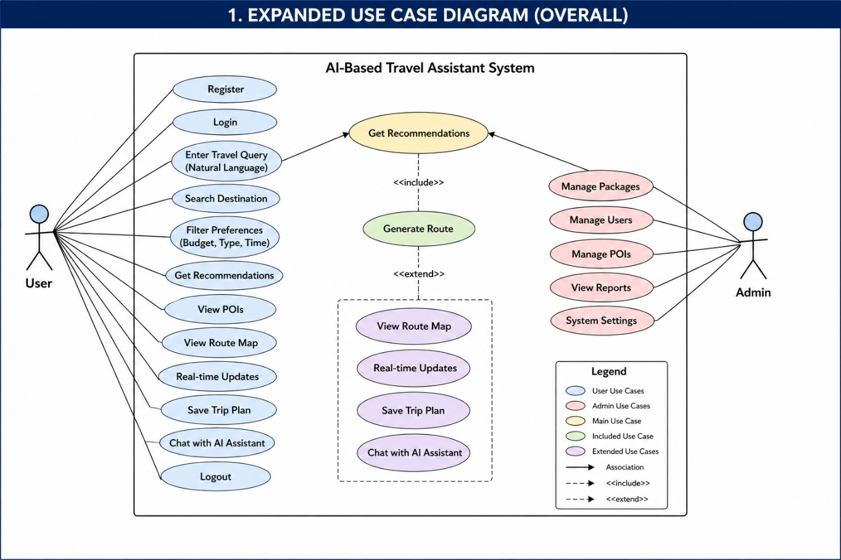
Figure 3.1: Use Case Diagram of AI-Based Travel Assistant System
3.2. Functional Requirements
Functional requirements define the core operations that the system must perform.
User Account Management
FR-3.2.1: The system shall allow users to register using valid credentials.
FR-3.2.2: The system shall allow registered users to log in securely.
FR-3.2.3: The system shall allow users to update their profile information.
Travel Query Processing
FR-3.2.4: The system shall allow users to enter travel queries using natural language.
FR-3.2.5: The system shall process user input using NLP techniques.
FR-3.2.6: The system shall extract user preferences and relevant keywords from the input.
Route and Recommendation Module
FR-3.2.7: The system shall generate optimized travel routes.
FR-3.2.8: The system shall provide personalized travel recommendations.
FR-3.2.9: The system shall display relevant Points of Interest (POIs) along the route.
FR-3.2.10: The system shall allow users to view POI details such as name and category.
System Interaction Features
FR-3.2.11: The system shall provide real-time updates related to routes and locations.
FR-3.2.12: The system shall allow users to save and manage their trip plans.
FR-3.2.13: The system shall provide chatbot assistance for user queries.
Admin Functionalities
FR-3.2.14: The admin shall manage user data and accounts.
FR-3.2.15: The admin shall manage travel packages and POIs.
FR-3.2.16: The admin shall view system reports and analytics.

3.3. Non-Functional Requirements
Non-functional requirements define the quality and performance aspects of the system.
Performance
NFR-3.3.1: The system should generate recommendations and routes within an acceptable time.
NFR-3.3.2: The system should efficiently handle multiple users simultaneously.
Security
NFR-3.3.3: User data shall be securely stored and encrypted.
NFR-3.3.4: The system shall prevent unauthorized access.
Reliability
NFR-3.3.8: The system should operate consistently without failures or crashes.

3.4. Sequence Diagram
A sequence diagram represents the step-by-step interaction between different system components over time. It shows how data flows within the system and how different modules collaborate to fulfill a user request.
In the AI-Based Travel Assistant System, the sequence diagram illustrates the process of generating travel recommendations and routes based on user input. The main components involved in this interaction are:
• User
• Mobile Application (Flutter)
• NLP Module (Python)
• Recommendation Engine
• Database (MySQL)
• Route Engine (Map API)
• External API (POI/Maps Services)
The sequence of operations is as follows:
- The User enters a travel query in natural language through the mobile application.
- The Mobile Application sends the query to the NLP Module for processing.
- The NLP Module analyzes the input, extracts relevant keywords, and identifies user preferences such as location, budget, and travel type.
- The processed data is forwarded to the Recommendation Engine.
- The Recommendation Engine requests relevant data from the Database, including user history and available Points of Interest (POIs).
- The Database returns the required data to the recommendation module.
- The Recommendation Engine then requests route generation from the Route Engine.
- The Route Engine interacts with external mapping services (APIs) to calculate the optimal route and fetch route-related data.
- The external API returns route details and nearby POIs to the Route Engine.
- The Route Engine sends the generated route back to the Recommendation Engine.
- The Recommendation Engine combines route data with filtered recommendations and sends the final results to the Mobile Application.
- The Mobile Application displays the recommendations, route map, and POIs to the User.
This sequence ensures smooth communication between system components and highlights how user input is transformed into meaningful travel recommendations and routes.

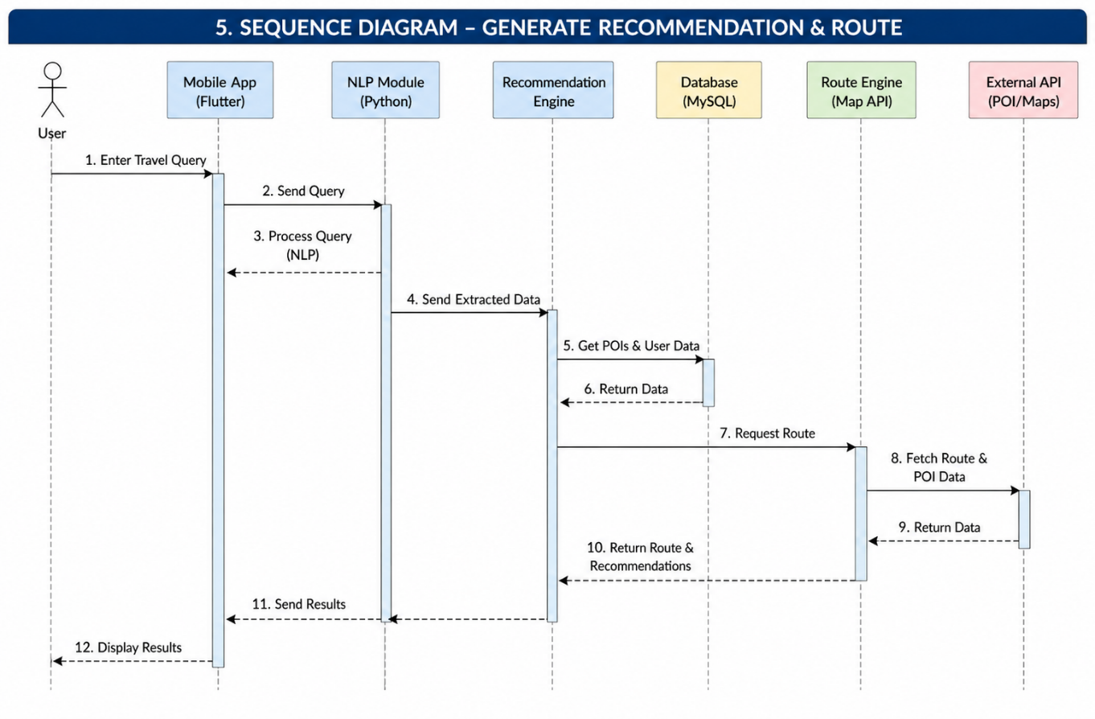
Figure 3.2: Sequence Diagram of AI-Based Travel Assistant System
3.5. Activity Diagram
An activity diagram represents the workflow of a system by illustrating the sequence of activities and decision points involved in completing a process. It helps in understanding the overall system behavior and the flow of control from one activity to another.
In the AI-Based Travel Assistant System, the activity diagram demonstrates the complete travel planning process from user interaction to final output. It highlights how the system processes user input and generates results step by step.
The workflow of the system is described as follows:
- The process begins when the User starts the application.
- The user performs Login or Registration to access system features.
- After successful authentication, the user enters a travel query using natural language.
- The system then processes the input using NLP techniques to understand user requirements.
- Based on the extracted information, the system generates travel recommendations.
- The system then generates an optimized route according to user preferences.
- The results, including recommended locations and route map, are displayed to the user.
At this stage, a decision point occurs:
• If the user is satisfied, they proceed to save the trip plan.
• If the user is not satisfied, they can modify their query or preferences, and the process repeats from the input stage.
- After saving the plan, the process ends successfully.
This activity diagram clearly shows the logical flow of operations, including user decisions and system responses. It also highlights the iterative nature of the system, where users can refine their input to achieve better results.

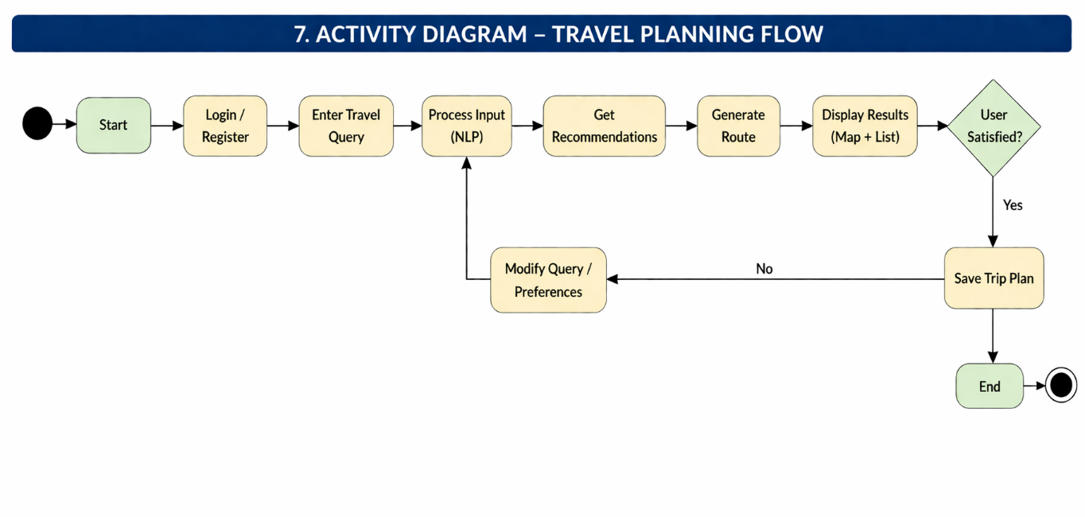
Figure 3.3: Activity Diagram of AI-Based Travel Assistant System
3.6. Class Diagram
A class diagram represents the structure of the system by showing different classes, their attributes, methods, and relationships. It helps in understanding how data is organized and how different components interact with each other.
In the AI-Based Travel Assistant System, the main classes include User, Travel Plan, Location, Route, and Recommendation Engine.
• The User class stores user information such as name, email, password, and preferences. It also provides functions like registration, login, and profile management.
• The Travel Plan class represents the user’s travel plan. It contains details like plan title, dates, and budget. A user can create and manage multiple travel plans.
• The Location class stores information about places, including name, type, and coordinates (latitude and longitude). These locations are used to build travel plans.
• The Route class represents the path between different locations. It includes details such as distance, duration, and starting/ending points.
• The Recommendation Engine class is responsible for generating travel suggestions based on user preferences and selected locations.
Relationships:
- A User can create one or more Travel Plans.
- A Travel Plan includes multiple Locations.
- A Travel Plan has one Route.
- The Recommendation Engine provides suggestions to improve the travel plan.
Overall, the class diagram provides a clear and simple structure of the system, showing how different components are connected and how they work together to support travel planning.
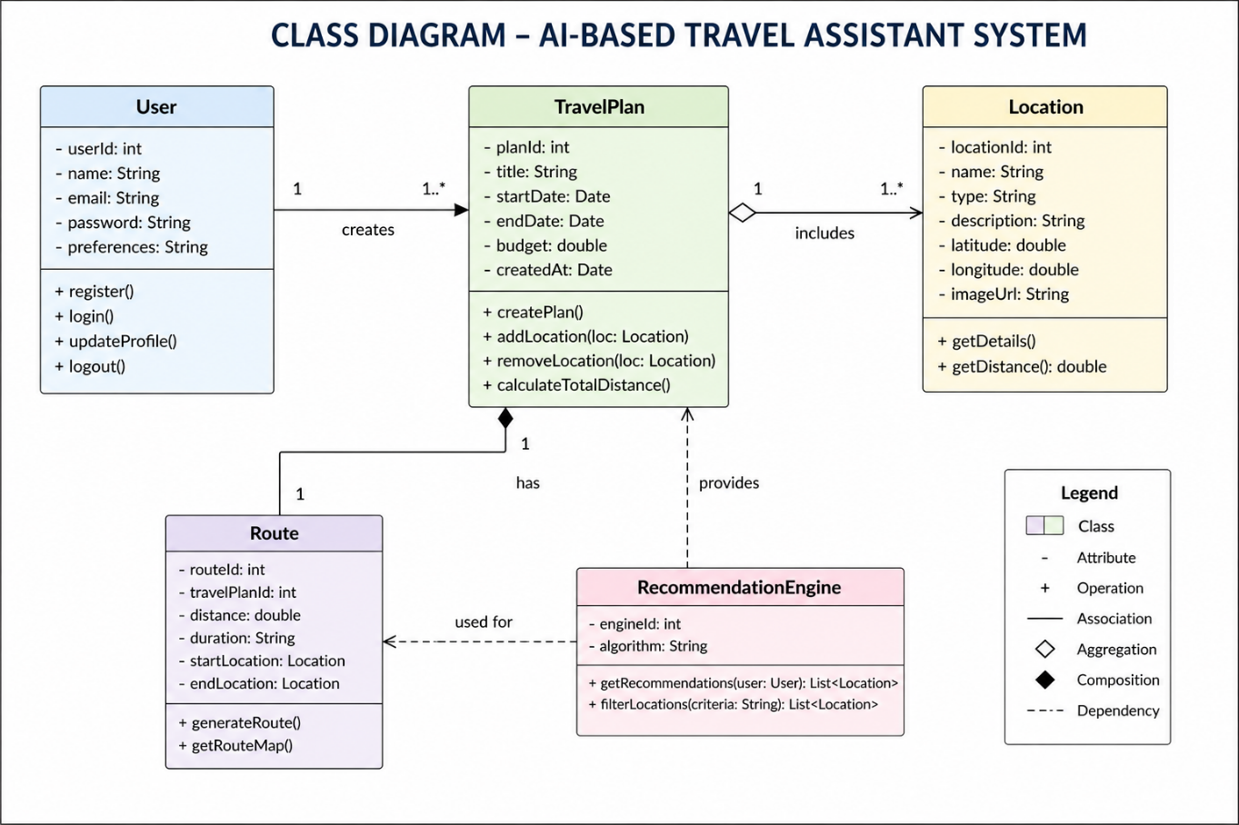
Figure 3.4: Class Diagram of AI-Based Travel Assistant System
3.7. Roles Diagram
A roles diagram represents the different roles involved in the system and their responsibilities. It helps in understanding how each role interacts with the system and what tasks they are responsible for.
In the AI-Based Travel Assistant System, there are three main roles: User, Admin, and AI System.
• The User is the primary actor who interacts with the system. The user can register, log in, enter travel queries, search destinations, get recommendations, view routes and Points of Interest (POIs), and save trip plans. The user can also interact with the AI assistant for guidance.
• The Admin is responsible for managing and maintaining the system. The admin can manage user accounts, update travel packages, manage Points of Interest data, view system reports, and control system settings.
• The AI System plays the role of processing and decision-making. It analyzes user input using Natural Language Processing (NLP), extracts preferences, filters relevant locations, generates optimized routes, and provides personalized recommendations.
Overall, the roles diagram clearly defines the responsibilities of each role and shows how they contribute to the working of the system.

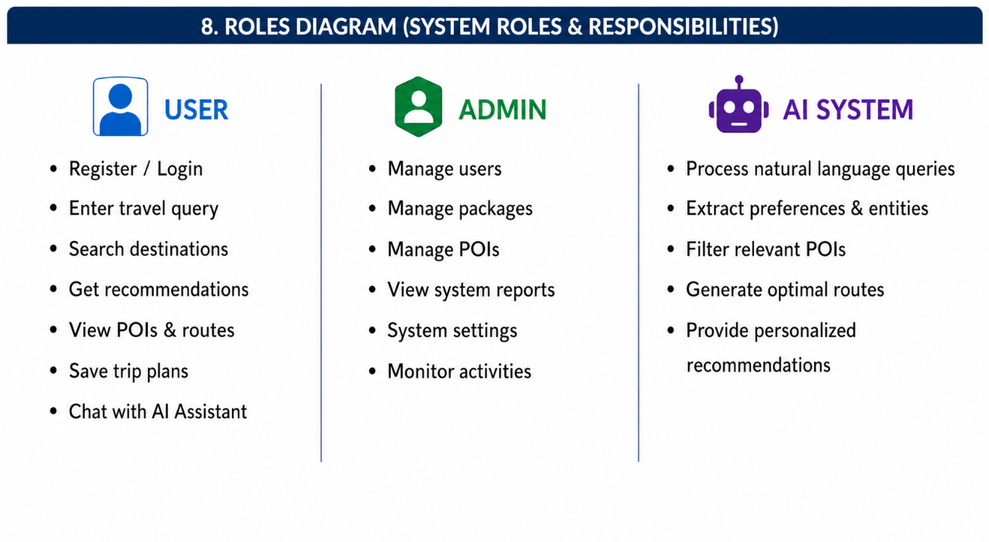
Figure 3.5: Roles Diagram of AI-Based Travel Assistant System

References
- • “Tourism Recommendation System: A Systematic Review,” International Journal of Engineering Research & Technology (IJERT), 2021.
- • “Artificial Intelligence in Tourism: A Systematic Literature Review and Future Research Agenda,” Sustainability (MDPI), 2025.
- • “A Systematic Survey of Tourism Recommender System Techniques and Challenges,” Journal of IoT in Social, Mobile, Analytics, and Cloud, 2022.
- • “Machine Learning Predictive Model for an Intelligent Tourism Recommendation System,” Journal of Applied Research and Technology, 2025.
- • “A Hybrid Tourism Recommendation System with Modified Similarity and Weighted Popularity Scores,” American International Journal of Computer Science and Technology, 2026.
- • “Artificial Intelligence Innovation of Tourism Businesses,” International Journal of Information Management, 2024.
- • “Smart Tourism Recommendation Model: A Systematic Literature Review,” International Journal of Advanced Computer Science and Applications, 2021.
- • “Artificial Intelligence Systems Applied to Tourism: A Survey,” arXiv, 2020.
- • “Recommendation Systems for Tourism Based on Social Networks: A Survey,” arXiv, 2019.
- • “Travel Agent: An AI Assistant for Personalized Travel Planning,” arXiv, 2024.
- • “Enhancing Tourism Recommender Systems for Sustainable City Trips Using Retrieval-Augmented Generation,” arXiv, 2024.
- • “Context-Aware Recommender Systems for Tourism,” IEEE Access, 2020.
- • “Location-Based Recommendation System for Tourism Using GPS Data,” Springer, 2021.
- • “Deep Learning-Based Tourist Destination Recommendation System,” Elsevier, 2022.
- • “Collaborative Filtering for Personalized Travel Recommendation,” ACM Transactions on Information Systems, 2020.
- • “AI-Based Chatbot for Travel and Tourism Assistance,” Procedia Computer Science, 2021.
- • “Intelligent Route Planning Using A* Algorithm for Tourism,” IEEE Conference Proceedings, 2020.
- • “Geospatial Data-Based Travel Itinerary Planning System,” Applied Sciences, 2023.
- • “POI Recommendation System Using Big Data Analytics,” Future Generation Computer Systems, 2022.
- • “Natural Language Processing for Smart Travel Planning Systems,” Journal of Artificial Intelligence Research, 2023.

